# Automation in Penetration Testing: Pros, Cons, and Best Practices

Cybersecurity, Manual vs Auto, Strategy, Culture, Hybrid Approach

September 5, 2023

[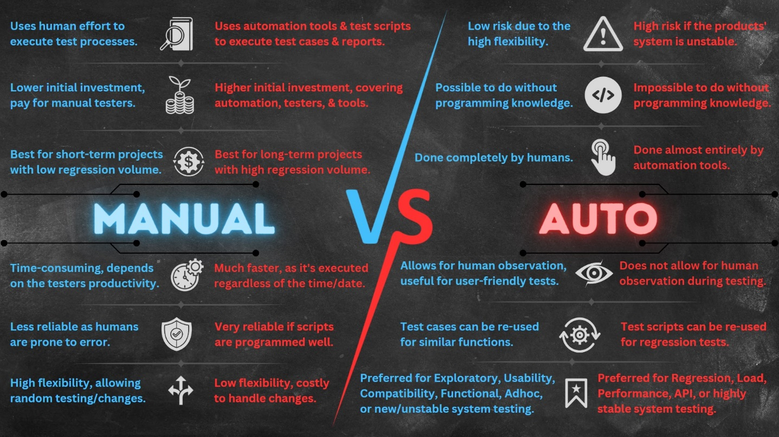](https://user-images.githubusercontent.com/131223318/265810377-2219bd65-99ab-4366-a6d4-0a7a62cf2720.jpg)

In an age where the digital realm is both a battleground and a treasure trove, cybersecurity has never been more paramount. As the protectors of invaluable data and digital assets, organizations are constantly challenged to stay one step ahead of cyber threats. Enter penetration testing - while this practice has long been a stalwart in the defense against cyber threats, it has recently undergone a profound transformation. The evolution comes in the form of automation, which has redefined the landscape of penetration testing, promising both accelerated detection and enhanced precision. Together, we will explore the profound advantages, weigh the inherent limitations, and uncover the best practices that herald a new era in penetration testing.

## Automation in Penetration Testing

Penetration testing, sometimes colloquially known as ethical hacking, is a cybersecurity practice that has rapidly evolved to become a cornerstone in safeguarding digital assets and sensitive data. Its fundamental purpose is to mimic real-world cyberattacks, scrutinizing an organization's system infrastructure, applications, and network for vulnerabilities that could potentially be exploited by malicious actors. Traditionally, this process relied heavily on manual intervention, where skilled cybersecurity professionals meticulously probed systems and networks in search of weaknesses. While effective, this manual approach was labor-intensive and time-consuming, often requiring substantial resources to complete thoroughly.

With the cybersecurity landscape continuing to evolve, the demand for innovative solutions to keep pace with these changes could not be more prevelant. This is where automation has emerged as a game-changer in the field of penetration testing. Automation, in this context, refers to the use of specialized software tools and scripts that autonomously and systematically scan, probe, and test an organization's digital infrastructure for vulnerabilities. It represents a paradigm shift, revolutionizing the traditional, manual methods by streamlining and accelerating the entire penetration testing process.

Automation in penetration testing brings forth a plethora of advantages that have the potential to transform the way organizations secure their digital assets. It is crucial to recognize how automation augments the penetration testing process, offering a multifaceted approach to identifying and addressing vulnerabilities.

## Pros of Automation in Pentesting

Automation in penetration testing offers a multitude of advantages that fundamentally enhance an organization's ability to safeguard its digital assets. Let's delve deeper into each of these pros to understand how automation revolutionizes the practice:

* **Speed & Efficiency**: Automation tools are akin to the speed demons of the penetration testing world. They can execute tests at a pace that surpasses human capabilities by orders of magnitude. This rapid execution translates to swifter identification of vulnerabilities, reducing the time between detection and mitigation. In a world where cyber threats evolve rapidly, automation's speed is a crucial asset.
* **Coverage**: Automation casts a wide net over an organization's digital landscape. Unlike manual testing, which often necessitates a focus on specific areas due to resource constraints, automation can perform a multitude of tests simultaneously. This comprehensive coverage extends to various attack vectors, including network configurations, web applications, and database vulnerabilities. It ensures that vulnerabilities across the entire attack surface are identified, leaving no stone unturned.
* **Consistency**: Human testers, no matter how skilled, are susceptible to inconsistencies and biases. Automation, on the other hand, is the embodiment of consistency. Automated tests follow predefined protocols with exacting precision, ensuring that every test is conducted uniformly. This consistency not only reduces the risk of overlooking vulnerabilities but also enhances the reliability of the results.
* **Repeatablility**: The ability to repeat tests is a critical feature of automation. Organizations can execute the same tests as frequently as desired, enabling them to conduct regular assessments of their security posture. This repeatability is invaluable for tracking improvements over time and ensuring that vulnerabilities are promptly addressed before they can be exploited.
* **Scalability**: As organizations grow, so do their digital footprints. Automation possesses the inherent capability to scale seamlessly. It can adapt to the increased complexity and size of systems without requiring a proportional increase in resources. This scalability is particularly advantageous for enterprises with vast and intricate digital infrastructures.
* **Data Analysis**: Automation tools don't just identify vulnerabilities; they provide comprehensive data analysis. These tools generate detailed reports that not only list vulnerabilities but also offer insights into their severity, potential impact, and recommended mitigation strategies. Such data-driven analysis empowers organizations to make informed decisions about which vulnerabilities to prioritize and how to allocate resources effectively.

In essence, the pros of automation in penetration testing boil down to efficiency, comprehensiveness, and reliability. Automation stands as a potent force that not only speeds up the process but also ensures that no vulnerabilities slip through the cracks. However, it's essential to remember that while automation brings remarkable advantages, it is not without its limitations and must be used judiciously in conjunction with other cybersecurity practices.

## Cons of Automation in Pentesting

While automation in penetration testing offers an array of benefits, it is crucial to recognize its limitations and potential pitfalls. Understanding these drawbacks is crucial for making informed decisions about when and how to leverage automation. Here are the cons of automation in penetration testing:

* **Limited Contextual Understanding**: One of the inherent limitations of automation tools is their reliance on predefined algorithms and patterns. While they excel at identifying known vulnerabilities and common attack vectors, they often lack the contextual understanding and the human intuition necessary to identify more subtle or unique vulnerabilities. Certain vulnerabilities may require an understanding of the specific organization's business processes, user behaviors, or industry nuances. Automation tools may miss these vulnerabilities, as they typically operate without this contextual awareness.
* **False Positives/Negatives**: Automated scans can produce false positives and false negatives, which can be a significant challenge for penetration testers. False positives occur when the tool incorrectly identifies a vulnerability that doesn't exist, leading to wasted time and resources investigating non-issues. On the other hand, false negatives occur when the tool fails to detect a genuine vulnerability, leaving the organization exposed to potential threats. Both false positives and false negatives are common in automated testing and necessitate human validation to confirm or refute the findings.
* **Complexity Handling**: Some vulnerabilities are inherently intricate, involving multifaceted systems or intricate configurations. These complex vulnerabilities often require manual inspection and in-depth analysis to validate their existence and assess their impact accurately. Automation tools may struggle to handle such complexity effectively. As a result, relying solely on automation in these scenarios can lead to incomplete assessments and a false sense of security.
* **Inadequate Testing of Logic Flaws**: Automated tools excel at identifying vulnerabilities that involve well-known patterns, such as SQL injection or cross-site scripting. However, they may struggle to identify logic flaws that don't conform to these established patterns. Logic flaws are vulnerabilities that occur due to flaws in the application's design or business logic, and they can be challenging to detect through automated scanning alone. These flaws often require manual testing and a deep understanding of the application's functionality to uncover. Ignoring logic flaws can leave critical vulnerabilities undetected.

The cons of automation in penetration testing primarily revolve around its limitations in handling nuanced vulnerabilities, its propensity for false positives and negatives, and its struggles with complex and logic-based vulnerabilities. To mitigate these limitations, a balanced approach that combines the strengths of automation with human expertise is often recommended. Human testers can provide the contextual understanding, critical thinking, and in-depth analysis necessary to complement the efficiency of automation and ensure a more thorough assessment of an organization's security posture.

## Best Practices for Implementing Automation

Implementing automation in penetration testing is a strategic move that can significantly enhance an organization's cybersecurity posture. However, to reap the full benefits while minimizing potential drawbacks, it's crucial to follow best practices tailored to the unique requirements and challenges of your organization. Here are the key best practices for effectively implementing automation in penetration testing:

* **Hybrid Approach**: Both automation and manual testing each bring distinct advantages to the table. Combining the two into a hybrid approach is often the most effective strategy. Automation excels at quickly identifying common vulnerabilities across a broad spectrum of systems. Simultaneously, manual testing provides the critical human element necessary to address complex issues and offer contextual insight into vulnerabilities. The synergy of automation and human expertise ensures a more comprehensive assessment.
* **Tool Selection**: Carefully select automation tools that align with your organization's technology stack and needs. Not all tools are created equal, and some may be better suited for specific environments or types of testing. Assess the comprehensiveness of a tool's vulnerability database to ensure it covers the potential weaknesses relevant to your systems. The compatibility of the tool with your existing infrastructure is equally vital to streamline the testing process.
* **Regular Updates**: Keep your automation tools up to date with the latest threat intelligence. Cyber threats evolve rapidly, and automation tools must stay in sync with emerging vulnerabilities and attack techniques. Regularly updating your tools ensures that they can effectively identify and assess the most recent security risks, providing your organization with real-time protection.
* **Customization**: Resist the temptation to rely solely on generic, out-of-the-box automated scans. While automation can identify common vulnerabilities, your organization may have unique configurations or applications that require tailored testing. Customize your automated tests to suit your specific needs, ensuring that vulnerabilities unique to your environment are not overlooked. This customization improves the accuracy and relevance of the results.
* **Human Validation**: Human validation plays a critical role in minimizing the impact of false positives and negatives generated by automation. Skilled penetration testers should review the results of automated scans, adding a layer of expertise that can differentiate between real vulnerabilities and false alarms. This validation process enhances the reliability of the findings and ensures that resources are focused on addressing genuine security risks.
* **Continuous Learning**: The field of cybersecurity is dynamic, and automation tools and techniques evolve constantly. Keep your penetration testing team trained and updated on the latest advancements in automation tools and methodologies. Encourage continuous learning and certification to ensure that your team maximizes the benefits of automation and remains well-equipped to address emerging threats effectively.

By adhering to these best practices, organizations can harness the power of automation in penetration testing while mitigating potential pitfalls. The combination of automation's efficiency and human expertise's depth ensures a robust defense against evolving cyber threats, ultimately safeguarding digital assets and sensitive data effectively.

## Reflecting

Automation has revolutionized penetration testing, offering speed, efficiency, and comprehensive coverage. However, it's important to recognize its limitations, such as the inability to grasp context and susceptibility to false results. To maximize its benefits, a balanced approach that combines automation's strengths with human expertise is crucial. This fusion ensures the best of both worlds and reminds us that automation is a tool, not a panacea.

Selecting the right tools, keeping them updated, customizing tests, validating results, and fostering a culture of continuous learning are essential for successful automation. The integration of automation into penetration testing represents a formidable ally in fortifying digital defenses, but it is the synergy of automation and human acumen that guarantees the resilience of our digital ecosystems. Together, we embark on this journey toward a more secure digital future.

# Resources:

* [[Click Here]](https://purplesec.us/learn/automating-penetration-testing/#:~:text=Automated%20penetration%20testing%20is%20when,and%20web%20and%20mobile%20applications.) *PurpleSec: Why Automation Is The Future Of Penetration Testing? (2022)*
* [[Click Here]](https://www.comparitech.com/net-admin/best-automated-penetration-testing-tools/) *Comparitech: The Best Automated Penetration Testing Tools (2023)*
* [[Click Here]](https://www.apisec.ai/blog/penetration-testing-best-practices) *APIsec: Penetration Testing Best Practices for Every Stage of Testing (2022)*
* [[Click Here]](https://www.eccouncil.org/cybersecurity-exchange/penetration-testing/penetration-testing-best-practices-enterprise/) *EC-Council: Best Practices for Conducting Effective Penetration Tests on Enterprise Networks (2023)*
* [[Click Here]](https://csrc.nist.gov/nist-cyber-history/automation-metrics/chapter) *NIST: Automation and Vulnerability Management (2020)*
* [[Click Here]](https://www.techtarget.com/searchsecurity/feature/Pros-and-cons-of-manual-vs-automated-penetration-testing) *TechTarget: Pros and cons of manual vs. automated penetration testing (2022)*
* [[Click Here]](https://blog.securelayer7.net/automated-vs-manual-pen-testing/) *Securelayer7: Automated Vs Manual Pen-Testing – What’s The Difference? (2023)*
* [[Click Here]](https://u-tor.com/topic/automated-penetration-testing) *U-Tor: What is Automated Penetration Testing and How Does It Help? (2021)*
* [[Click Here]](https://csrc.nist.gov/glossary/term/penetration_testing#:~:text=Definitions%3A,data%2C%20or%20its%20environment%20resources.) *NIST: Penetration Testing*
* [[Click Here]](https://www.getastra.com/blog/security-audit/automated-penetration-testing/) *Astra Security: What is Automated Penetration Testing? Difference between Automatic & Manual Pentesting (2023)*